A Personal Environment Network is a network of ad-hoc devices that organize themselves into an active network to exchange information that is determined by each individual device. How do you create one?

Use Case 1:

This Personal Environment Network is a classroom with students as users. The classroom has a temperature sensor that gives the temperature of the environment within 1 square foot. The students are allowed to find a comfortable area for their duration in the environment. Video and audio sensors provide audio and video recordings of all the lecture material presented by the instructor. The references that the instructor gives to the students are received by the information sensor. All the material written on the whiteboards during the duration of the environment are captured by the whiteboard sensors. Information about students’ hobbies are released to the user information sensors. Holographic images of the students in the classroom are made available. The instructor’s information is released as the Instructor CV. The recordings of presentation material presented by the instructor are released as a video presentation. User owned whiteboard enable a user friendly environment for an ad-hoc way of presenting ideas.

Components:

1. The environment is a mobile ad hoc network (MANET). It is a self-configuring infrastructure-less network of mobile devices connected by wireless links. This environment allows users to use devices with sensors. The sensors are able to find information about the environment such as the temperature (within 1 square foot), video recordings, audio recordings, whiteboards, and user whiteboards.
2. The users are stand-ins for students who use the devices. They each have user information which contains their hobbies, likes, dislikes, their major, etc. Other students can check their user information to see if they have anything in common. They each have a user whiteboard that has the ideas they want to present to the instructor or other classmates.
3. The devices are the objects that users need to communicate with each other. They know all sensor types and have a user interface that creates a connection between the sensor environment and the user. The device gives the user information to make decisions based on what the sensor picks up.
4. The receiving sensors need to activate by transmitting the id, type, capabilities, and priority. This process takes less than one second. They sense the temperature in the environment and give the user to choose a good area to be in. The receiving sensors get audio recordings for the lecture material created by the instructor and video recordings of the content in the environment. They get the material on all whiteboards in the environment. The receiving sensors also get information about references the instructor gives (from books, passages and other sources).
5. The transmitting sensors give information about the temperature in the environment to the users. They also give information about video and audio recordings to the users. Transmitting sensors give user information (about other users) to users. They give information of other users’ whiteboards to the user.

Use Case: Classroom Environment

Primary actor: Student

Goal in context: To create a classroom environment and enable the students to use devices to communicate to one another.

Preconditions: The devices have sensors that to let them know what is going on with the environment.

Trigger: The users need to be in a bounded space to use their devices.

Scenario:

1. Student: gets references from the instructor.
2. Student: gets video recording of all content in the environment.
3. Student: gets audio link of lecture material from instructor.
4. Student: gets material from whiteboards.
5. Student: gets information about other students.

Use Case 2:

This Personal Environment Network is a store that has employees and customers. It has a layout map that has an internal networking sensor system that maps the entire store by category location. A user wish list determines the items that are of interest to the customer and know where these items are. The cost-comparison sensors give information of items and compare them to each other to see which is the best pick for the customer. The decision sensor finds items of interest that the customer needs by seeing the layout of the customer’s items and home. The whiteboard sensor get material on any of the whiteboards during the duration of the environment. The user information sensor allows the customer to get the sales department and sales people to get specific items or answer specific questions. The check out sensor allow the customer to check out an item without going to a checkout counter. Video/audio sensors allow for the customer to demo any device in the store without getting an employee to set up a demo.

Components:

1. The environment is a mobile ad hoc network (MANET). It is a self-configuring infrastructure-less network of mobile devices connected by wireless links. This environment allows users to use devices with sensors. The sensors are able to find information about the environment such as the layout, video demos, audio demos, whiteboards, and user information.
2. The users are stand-ins for customers who use the devices. They each have user information which contains the interests of the user and what items they want to buy. They each have user information sensors that has the interests they have to present to the sales group.
3. The devices are the objects that users need to communicate with each other. They know all sensor types and have a user interface that creates a connection between the sensor environment and the user. The device gives the user information to make decisions based on what the sensor picks up. In this case, the device gives the user (customer) information about the home environment, allows the user to check out an item, demo any device, put items on a wish list, and compare the costs of sensors.
4. The receiving sensors need to activate by transmitting the id, type, capabilities, and priority. This process takes less than one second. They give the layout of the store by category location. The receiving sensors determine what items are of interest to the user. They get the cost of items that are relevant to the customer and compare them. The receiving sensors also analyzes the layout of the user’s home and determines if the user needs any items (and if they actually work in the user’s home).
5. The transmitting sensors give information about the store layout to the users (includes the category locations). They also give information about demos to the users. Transmitting sensors enable users to check out an item without going to a checkout counter. They give information of other users’ whiteboards to the user.

High-level use case diagram:

Swimlane Diagram:

List of items:

Class diagram:

|  |
| --- |
| Classroom |
| studentID |
| classroomTemperature |
| videoRecording |
| audioRecording |
| studentInformation |
| whiteBoard |
| userInformation |
| holographicImages |
| instructorBio |
| videoPresentation |
| studentWhiteboard |
| infoReferences() |
| classTemp() |
| bioInstructor() |
| presentVideo() |
| displayUserWhiteboard() |
| displayWhiteboard() |
| studentInfo() |

2nd class diagram:

Use Case: Electronics Store Environment

Primary actor: Customer

Goal in context: To create a Store Layout Map and enable the customers to use devices to buy items (or have an easier time doing so).

Preconditions: The devices have sensors that to let them know what is going on with the environment.

Trigger: The users need to be in a bounded space to use their devices.

Scenario:

1. Customer: gets information for items to compare and contrast with others (such as the cost).
2. Customer: gets to check out an item without going a checkout counter.
3. Customer: gets to demo any device with having an employee set up a demo.

High-level use case diagram:

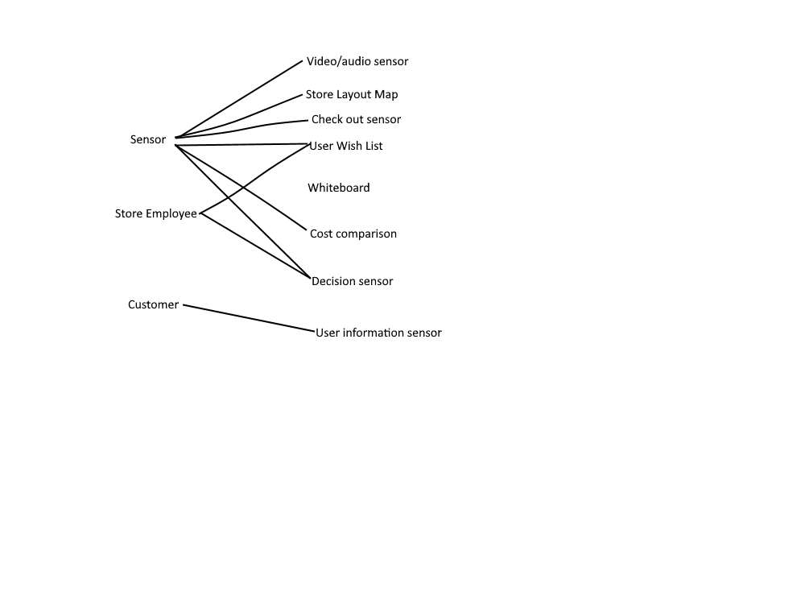

Swimlane Diagram:

List of items:

Class diagram:

|  |
| --- |
| Store |
| customerID |
| storeMap |
| wishList |
| costComparison |
| customerDecision |
| whiteBoard |
| customerInfo |
| userCheckout |
| videoAudiodemos |
| customerInfo() |
| displayWhiteboard() |
| checkItem() |
| storeMap() |
| costComparison() |
| customerDecision() |
| displayWhiteboard() |
| userInfo() |
| demoDevice() |

2nd class diagram:

